**The OKC Story**

**by Justin Lorenzen**

**In 2020, the Oklahoma City Fire Department responded on 641 structure fires. Of those structure fires there were a total of 18 fire victims, 7 of which were on-scene fatalities. The remaining 11 victims were rescued by search, with 7 of them being removed from the structure with a pulse and 4 of them removed without a pulse. All 11 victims were treated and transported to the hospital. Patient condition beyond transport is unable to be tracked due to H.I.P.A.A.**

Traditionally, we only hear statistics on civilian fire fatalities but what about the ones we save, the ones for whom we make a difference? Why are we not sharing these outcomes? We’re not sharing them because we don’t have the information.

“There is a void of qualitative information in fire reporting, and a nearly absent basis of information on rescued victims. In 2016, a group of firefighters who had been collecting firefighter rescue reports decided that news reports alone were not providing enough detail in regard to where the victims were located, how they were removed, and the outcome. To address this gap, the group developed the Firefighter Rescue Survey.” (www.firefighterrescuesurvey.com)

So, what do we do about it? We spread the word and submit any rescues to Fire Fighter Rescue Survey. That may be easier said than done though. What if your department is not keen on the idea of incident information being submitted to a public platform like ours was? Municipalities have a duty to guard any and all data derived from their incident reports. Without proper knowledge of the Firefighter Rescue Survey purpose, one could have some concerns of how this data would be used for or if it would be used for profit. This reiterates the need to spread the word about Firefighter Rescue Survey and its true purpose!

“By recording the number and details of a rescue made on the fireground we will be able to tailor our training to methods and techniques of what actually works.  Improving our results to benefit the populations we serve.” (www.firefighterrescuesurvey.com)

Furthermore, Firefighter Rescue Survey was created to capture detailed data of our “wins”. The site was developed and is maintained by firefighters. This mission for these firefighters was so important to them that they developed and currently maintain the survey from money out of their own pockets.

After identifying the possible roadblocks, what do we do from here? Do we stop and just give up or do we search for an alternative method to capture this critical data while adhering to our departments’ policies? After all it is for THEM, right? The Oklahoma City Fire Department chose the latter of the two and started searching and this is what we found.

This is the Oklahoma City Fire Department’s Story….

When we first learned about FFRS a few years ago, we approached our command staff about allowing our members to submit our rescues on the website but there were concerns about putting Incident information on a public platform. This led us to find a way to somehow record our rescues that weren’t on a public platform.

The reporting system the OKCFD used didn’t capture the detailed data of these rescues. We knew we had to find a platform that was internal but also one that would capture the data we wanted. Other departments may already have a reporting system with those capabilities.

OKCFD uses Microsoft Office 365 for our email platform which allows access to other Microsoft Apps. This is where we found Microsoft Forms. By using Microsoft Forms, access to the OKCFD GRABS survey could only be obtained by signing in with a City of Oklahoma City employee email. This took care of any concern of Incident information being made public.

Microsoft Forms was very user friendly and made it easy to build our “OKCFD GRABS” survey. Google Forms is another platform that works very similarly and only requires a Gmail account to use.

We wanted our survey to capture the same data as FFRS so that, if allowed in the future, we could submit the information to the FFRS website. We downloaded the “List of Survey Questions” from the Firefighter Rescue Survey home page and used them as our template for our internal survey.

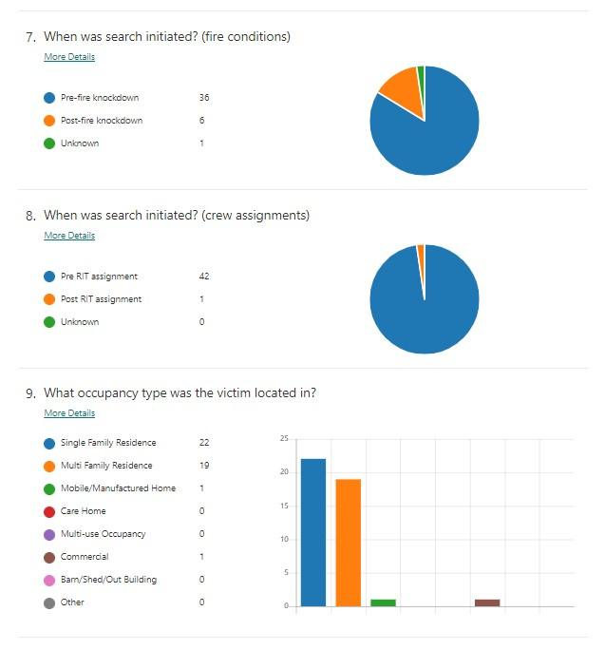Once a survey is submitted, Microsoft Forms automatically inputs the data into a pie/bar graph format. As the original creators/administrators of this internal survey, we have access to the “Responses” page that shows all submitted surveys in the graph form.

This is where any duplicate surveys can be deleted and/or edited. A link to this portion of the survey can be shared with any city employee to review the data collected in a “Read Only” format.

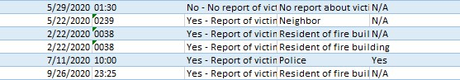

Microsoft Forms also allows the user to view the data in Excel. By viewing the data in Excel, it allows for filtering the results to specific parameters such as number of rescues in a specific year. Additionally, being in a .xlsx format allows for embedding into Google Maps.

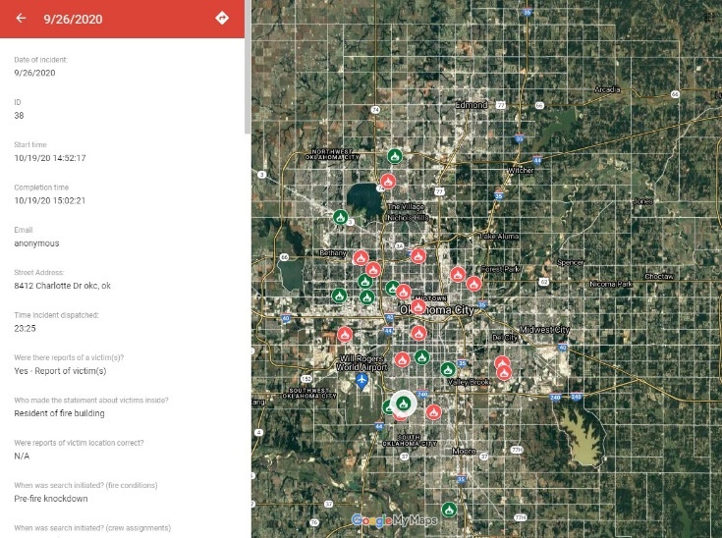Google Maps has a free option of creating a customized map with My Maps. We uploaded the .xlsx file to Google My Maps and set the location to “Incident address”. This allowed for each incident to appear at the actual address on the map.

By physically tracking our rescues on the map and comparing them with the data, we hope to possibly identify areas in the city that may need more fire safety education or installation of smoke detectors through our Project Life program.

Once the survey was built and ready to implement in our department, we created an OKCFD Grabs station poster. The poster explained the vision of the survey as well as included a QR code that could be scanned by any smart device that takes you straight to the survey. These were distributed to the stations. We wanted to have the survey as easily accessible as possible.



Since going live with this survey we have been able to give the department updates on the rescues our firefighters have made with raw data specific to our department. Being able to provide our firefighters with real data of victim location, arrival to victim times, removal times, cyanokit usage, etc. gives our citizens the best chance of survival.

This is a route one could propose if your department is hesitant to allow submission of a rescue on a public platform such as firefighterrescusesurvey.com. Since the conception of the Grabs survey on our internal platform, the data and information the Oklahoma City Fire Department collected proved the importance of the survey and now allows our rescues to be submitted on FFRS. We will still use our internal survey as well so that we can continue to provide our firefighters with department specific data.

Ultimately, the goal is to have all rescues recorded on the Fire Fighter Rescue Survey site on one central platform. For OKCFD, that initially wasn’t an option but eventually it led us there.

This article is intended to hopefully provide an alternative means of recording rescues if you find yourself encountering the same hurdle we did. By no means do we want to direct any department away from Fire Rescue Survey. We just wanted to share our experience in hopes that it could help other departments start recording their “wins” when there are no other options.